**PROJECT SYNOPSIS**

**SOFTWARE BASED PROJECT**

**PROJECT TOPIC** **:** MAHA-E-SEVA KENDRA

**NAME** : SAURABH SUBHASH PALKAR

**ROLL NO : 20**

1. **Introduction**:

Provide In an era characterized by rapid technological advancement, governments around the world are harnessing the power of digital platforms to streamline citizen services and foster greater transparency. The Government of Maharashtra, recognizing the need for a seamless interface between the administration and its citizens, introduced the MAHA-E-SEVA KENDRA. Translating to "Our Government" in Marathi, this online platform stands as a testament to the state's commitment to accessibility and efficiency in public service delivery.The MAHA-E-SEVA KENDRA portal serves as a virtual bridge, connecting millions of residents in Maharashtra with a plethora of government services and information at their fingertips. Through this platform, citizens can avail themselves of an array of services, ranging from vital document issuance to enrollment in various government schemes.

1. **Problem Statement**:

In today's fast-paced digital age, accessing and managing government services can often be a cumbersome and time-consuming process for citizens. The existing system in Maharashtra for availing government services is largely paper-based, requiring individuals to physically visit government offices, leading to long queues, delays, and inefficiencies. Additionally, the lack of a centralized digital platform results in a fragmented experience, making it challenging for citizens to navigate and avail services effectively.

This inefficiency in service delivery not only inconveniences citizens but also places a burden on government resources, leading to suboptimal utilization and extended processing times. Furthermore, it hinders the government's goal of providing accessible and efficient services to its citizens, ultimately affecting the overall citizen satisfaction and trust in governmental processes.

To address these challenges, our project aims to develop a comprehensive digital platform modeled after the successful " MAHA-E-SEVA KENDRA." initiative in Maharashtra. This platform will serve as a user-friendly portal, streamlining the process of accessing various government services and schemes, thereby enhancing citizen convenience and government efficiency.

1. **Objective**:

The primary objective of this project is to design and implement a user-friendly digital platform inspired by the " MAHA-E-SEVA KENDRA." initiative in Maharashtra. The platform aims to streamline the process of accessing government services, providing citizens with a convenient and efficient means of interaction with government departments. The key objectives of the project include:

* Develop an intuitive user interface for easy navigation and access to various government services and schemes.
* Implement secure user authentication and authorization mechanisms to safeguard sensitive information.
* Integrate features for online application submission, tracking, and status updates for government services.
* Provide a platform for citizens to submit feedback, suggestions, and register grievances for prompt redressal.
* Ensure compliance with relevant data protection and privacy regulations.

1. **Scope**:

The project will focus on creating a web-based application accessible through standard web browsers. It will include the following key components:

* User Registration and Authentication: Users will be able to create accounts and log in securely using their credentials.
* Service Catalog: A categorized list of government services and schemes available for citizens to access.
* Online Application Submission: Users will be able to fill out and submit applications for various services.
* Application Tracking: A feature allowing users to track the status of their submitted applications.
* Feedback and Grievance Submission: Users will have the ability to provide feedback, suggestions, and register grievances.
* Administrative Dashboard: An interface for government officials to manage and process incoming applications and feedback.

The project will not encompass the integration of external payment gateways or real-time processing of financial transactions. Additionally, it will not cover the development of mobile applications or offline functionality.

1. **Methodology**:

The project will follow an iterative development methodology based on the Agile framework. This approach emphasizes collaboration, adaptability, and delivering incremental improvements. The development process will be divided into sprints, each lasting two weeks. At the beginning of each sprint, a backlog of tasks will be defined based on priority, and the development team will work on completing these tasks within the sprint timeframe.

* Key stages of the development process will include:
  + **Requirement Analysis**: Understanding and documenting the specific needs and expectations of users, stakeholders, and government officials in relation to the portal's functionalities.
  + **Design and Prototyping**: Creating wireframes and design mockups to visualize the user interface and flow of the application. This will involve feedback loops to refine the design based on stakeholder input.
  + **Development**: Writing code for the frontend and backend components of the portal, implementing the identified features and functionalities.
  + **Testing**: Conducting comprehensive testing, including unit testing, integration testing, and user acceptance testing, to ensure the application functions as intended.
  + **Deployment**: Deploying the application on a hosting platform with considerations for scalability, security, and performance.
  + **User Acceptance and Feedback**: Providing stakeholders and end-users with an opportunity to review and provide feedback on the deployed application.
  + **Iteration and Improvement**: Based on feedback received, making necessary adjustments and improvements to the application in subsequent sprints.

1. **Components and Features**:

* **User Authentication and Registration**: Users can create accounts and log in securely to access personalized services.
* **Service Catalog**: A categorized list of government services and schemes with detailed descriptions.
* **Online Application Submission**: Users can fill out and submit applications for various services directly through the portal.
* **Application Tracking**: A feature that enables users to monitor the status and progress of their submitted applications.
* **Feedback and Grievance Submission**: Users have the ability to provide feedback, suggestions, and register grievances for government consideration.
* **Administrative Dashboard**: An interface for government officials to manage and process incoming applications and feedback.
* **User Profile Management**: Users can update their personal information, view application history, and manage communication preferences.
* **Search and Filter Functionality**: Users can easily search and filter services based on categories, keywords, or specific criteria.
* **Accessibility Features**: Tools and options to ensure the portal is accessible to users with disabilities.
* **Security Measures**: Implementation of security protocols (HTTPS) and measures to protect against common web vulnerabilities.

1. **Technologies Used**

* **Frontend Development**:
  + HTML5, CSS3, JavaScript, jquery and AJAX for building dynamic user interfaces
  + Bootstrap-5 for responsive design
* **Backend Development**:
  + PHP for server-side scripting
  + MYSQL database for efficient data storage
* **Authentication and Security**:
  + Ecrypt for password hashing
* **Version Control and Collaboration**:
  + Git for version control
  + GitHub for collaborative development and code management
* **Development Environment**:
  + Visual Studio Code as the preferred integrated development environment (IDE)

1. **Implementation Plan**:

* **Phase 1 (Weeks 1-2)**:
  + Requirement analysis and initial system design.
  + Setting up the development environment and version control.
* **Phase 2 (Weeks 3-4)**:
  + Frontend development: Creating UI components and user authentication.
  + Backend development: Setting up server, routing, and database integration.
* **Phase 3 (Weeks 5-6)**:
  + Implementing core features: Service catalog, application submission, and tracking functionality.
* **Phase 4 (Weeks 7-8)**:
  + Feedback and grievance submission, administrative dashbard development.
* **Phase 5 (Weeks 9-10)**:
  + Testing and quality assurance: Unit testing, integration testing, user acceptance testing.
* **Phase 6 (Weeks 11-12)**:
* User documentation preparation, final testing, and deployment.

1. **Testing and Quality Assurance**:

* **Unit Testing**:
  + Using Jest to test individual components and functions for correctness.
* **Integration Testing**:
  + Employing Supertest to verify the interaction between different modules of the application.
* **User Acceptance Testing (UAT)**:
  + Involving stakeholders and end-users to validate the functionality and usability of the application.
* **Security Testing**:
  + Conducting security assessments to identify and address vulnerabilities.
* **Performance Testing**:
* Assessing the system's responsiveness and scalability under various load conditions
  + Explain how you plan to test and ensure the quality of your project, including any testing frameworks or methodologies you will use.

1. **System Design**:

* **Database Design**:
  + Mysql will be used for database to store user profiles, application data, and feedback.
* **User Interfaces**:
  + The frontend will feature an intuitive and user-friendly interface with responsive design for seamless use on various devices.
* **Scalability and Performance**:
  + The system will be designed with scalability in mind to handle potential increases in user traffic.

1. **Expected Results and Benefits**

* **Improved Access to Government Services**:
  + Citizens will experience streamlined access to a wide range of government services and schemes.
* **Reduced Processing Time**:
  + The digital platform will significantly reduce the time required for processing applications and providing services.
* **Enhanced Citizen Satisfaction**:
  + Users will benefit from a more convenient and efficient interaction with government departments, leading to higher satisfaction levels.
* **Resource Optimization**:
  + The portal will optimize government resources by automating processes and reducing paperwork.
* **User Interface design:**
  + Login page:

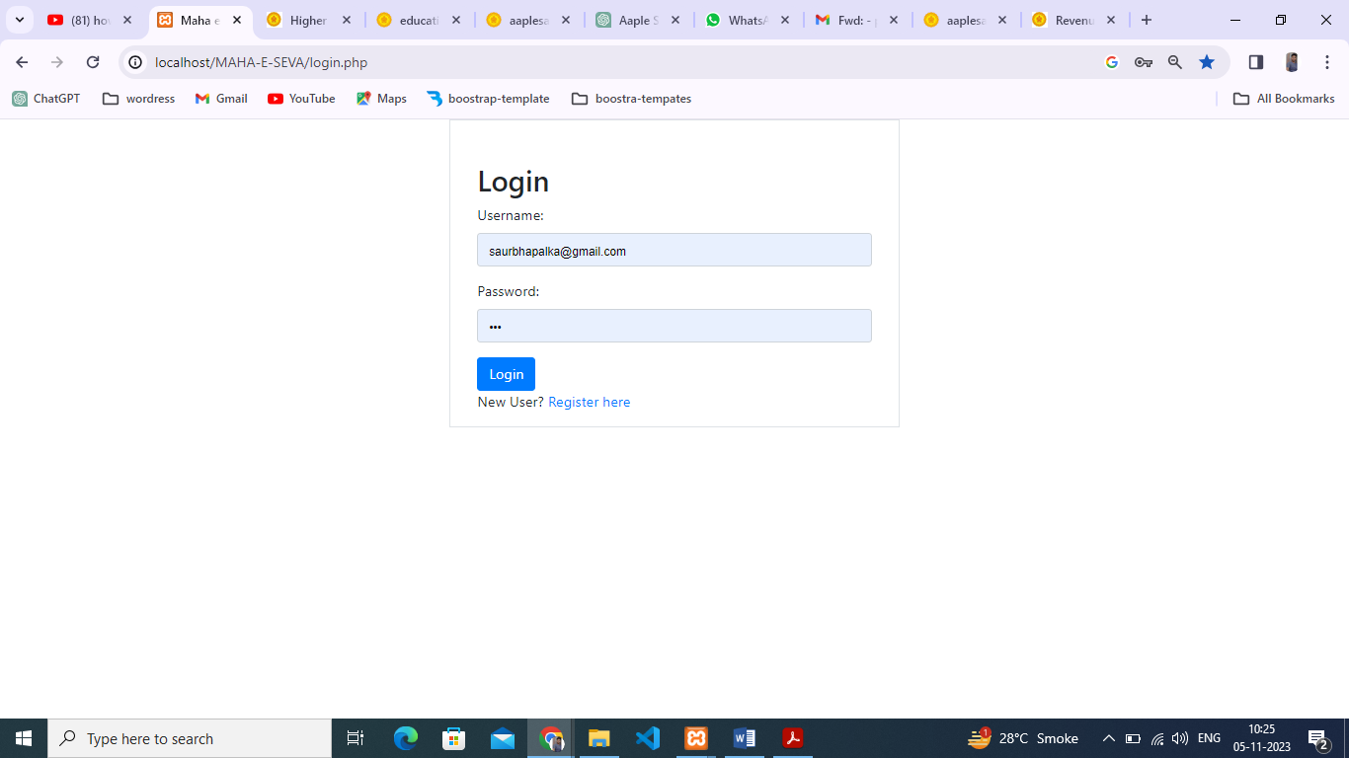

* + Dashboard Page: 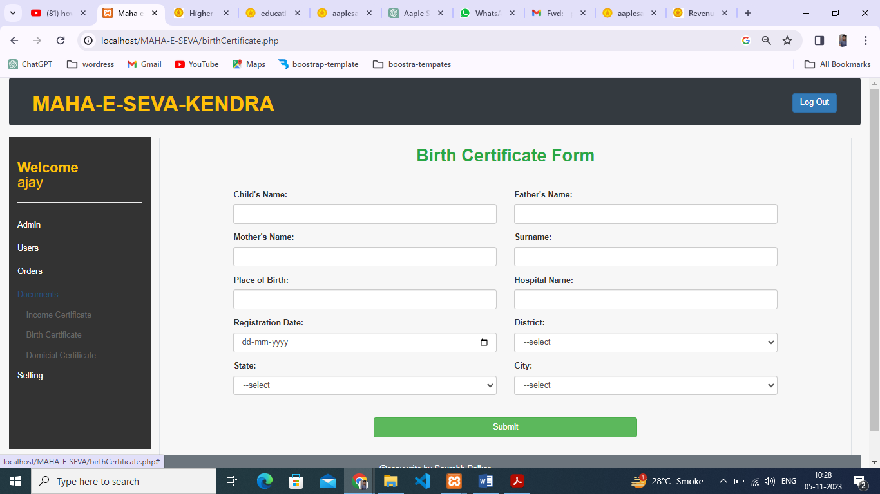

1. **Conclusion**

* In conclusion, the development of a user-friendly digital platform inspired by the "MAHA-E-SEVA KENDRA " initiative holds significant potential to revolutionize the way citizens interact with government services in Maharashtra. The project aims to address existing inefficiencies and enhance the overall experience for both citizens and government officials. By leveraging modern technologies and a user-centric approach, this initiative is poised to make a positive impact on the accessibility and efficiency of public services.

1. **References**

* Aaple Sarkar Portal
* Internet
* Visited to Common Service Center